AI-Powered Chatbot Based Ticketing System for Museums: Improving Visitor Experience and Operational Efficiency

Mohamed Aslam Pasha
Department of Computer Science, Bio-intelligence Lab
Presidency University
Bangalore, India
mohamedaslampasha6161@gmail.com
Vaseem B M
Department of Computer Science, Bio-intelligence Lab
Presidency University
Bangalore, India
vaseembm7@gmail.com
Ms. Smitha S P
Department of Computer Science, Bio-intelligence Lab
Presidency University
Bangalore, India
smitha.sp@presidencyuniversity.in
.
Kovuri Nizamuddin
Department of Computer Science, Bio-intelligence Lab
Presidency University
Bangalore, India
kovurinizam14@gmail.com

Abstract-The contemporary cultural industry requires fresh innovations to enhance visitor experience and make operations more efficient. This paper discusses the design and implementation of an AI-Powered Chatbot-Based Ticketing System for museums and cultural centers. Through the application of Natural Language Processing (NLP) and conversational AI, this system enables seamless, real-time communications where users can book reservations, purchase tickets, and inquire about exhibitions using natural language. The system is intended to minimize long queues, restrict human errors, and deliver a full, multilingual, and inclusive user experience. It also puts emphasis on security and privacy, incorporating secure payment options for contactless payments. Furthermore, the system offers museum administrators important real-time data on visitor numbers and revenue. Through the modernization of ticketing procedures,
the system significantly makes cultural heritage accessible to a diverse world public.

I. INTRODUCTION

Service digitalization is a key issue faced by contemporary institutions and museums are no exception. Nearly all of the brick and mortar ticketing systems are inefficient operationally – from waits in long stretches to hours one must wait, sometimes screaming only to be told we’re closed – or paying to ask a question or two. This diminishes the overall visitor's experience.

These issues can be solved by introducing smart automated ticketing system proposed in this project presentation leveraging its potential understanding through conversational AI. To achieve 24/7 personal support with human-feeling cadence but automated system velocity, accuracy and scalability NLP-driven chatbots provide a unique possibility. It's so much more than just raw transactions, introducing a lush conversational customer experience for information retrieval and complex bookings.

The objective of this study is to design and prototype a high-quality, reliable but adaptable system that can be utilized by multiple language and levels of computer literacy to have access for both domestic and international tourists. The following sections briefly describe system architecture, NLP modules, implementation plan and the effect of the systems on operational effectiveness and visitor satisfaction.

II. RELATED WORK

The use of AI in customer service is nothing new, but its use in cultural ticketing is still developing. The initial applications were related to web-oriented forms and managing databases. Recent advances in NLP and ML have led to some breakthroughs in building sophisticated chatbots.
The miracles chatbots can work to reduce customer service and response times, as far as e-commerce and tourism studies show (Ref 1).

Cultural industry, one of the first applications were used for exhibition guides and personalized recommendations (Ref 2). Our approach is different because it features these dialog capabilities seamlessly into the ticketing process that requires high precision and security as well as real-time database synchronization.

Today's ticketing systems, while operational, typically lack a natural language interface, and instead force users to follow rigid menus. As argued in this article, the presence of multilingual support directly accessible to each user in a booking engine of international tourism-oriented institutions is crucial (Ref. 3). Second, the focus on decision-making at the administration level through real-time analytics links user experience in face and business insight in back.

III. SYSTEM ARCHITECTURE

The Modular, Multi-Layer Architecture of AI-Powered Chatbot-Based Ticketing System for Museums to Achieve Flexibility, Scalability and Intelligent Automation. The solution utilizes AI, NLP, cloud-based services and secure data storage to transform an ostensibly complex and opaque experience into a user-friendly interactive exchange.

1.Frontend Layer

The Frontend represents the user interface through which the visitor will interact with the chatbot. It is designed to be responsive, using technologies such as HTML5, CSS3, JavaScript, or Flutter. With the help of the chatbot interface, users can ask questions regarding exhibitions, ticket prices, timings, and booking in a conversational format. The design is intended to be simple and accessible while promoting real-time engagement. The frontend interacts with the backend via secure REST APIs for the smooth and efficient exchange of data.

2. Backend Layer

The Frontend describes the user interface, with which the visitor communicates with the chatbot. It can be a responsive page, Angular, React (HTML5, CSS3, Javascript), Flutter etc. Through the chatbot interface, users can engage in a conversation to ask questions about exhibitions, prices of tickets or time (to see an exhibition) and booking. The intention is that it should have been simple and to some extent intuitive to use, but at the same time theoretical sound, but also engaging when viewed in real-time. The frontend and backend communicate through secure REST APIs to ensure seamless data transfer.

3. Data Layer

Information about users, museums, ticketing information and chat logs are stored in the Data Layer in structured and unstructured form. Persistence is achieved using MySQL or PostgreSQL for example. All communication is encrypted and secured by user access controls. The layer supports rapid data retrieval with chatbot response and encryption of tickets both with integrity and confidentiality.
4. Cloud Infrastructure
The application is hosted on AWS Cloud Services to enhance the reliability and scalability. Amazon EC2 to host servers, RDS for databases and S3 as a file and backup storage on AWS. There is cloud backend where there should be ongoing uptime and load balancing and continuation of scaling with high traffic.

5. Workflow Layer

The full process is displayed in the Workflow from user input until ticket confirmed. The chatbot deciphers chats input using the natural language interpretation, communicates with the backend to secure details about events and tickets, makes payments and produces a QR-encoded e-ticket. This means less reliance on humans and faster ticketing, resulting in an easy, smart, mistake-free experience for the museum guests.

IV. IMPLEMENTATION DETAILS

A.NLP Model Training

The efficacy of the bot really relies on how accurate its NLP engine is. The model is trained on a selected dataset of over 5,000 potential guest queries such as bookings, information requests and cancellations as well as FAQs. Transfer Learning was utilized, a basic model was used and finetuned by museum related lexico. The multilingualism is implemented by using either different models for each of the language, or a single multilingual transformer model wherein the latter was chosen for performance reasons.

B. Secure Transaction Flow

A transactional system should be secured as well. The payment is made through a standard secure method:

Confirmation: The Dialog Manager checks the booking information (date/time, amount of baskets, price).

Redirection/API Call: User is pushed to the payment gateway (or inline api call is made). https://www.paymentexpress.com/Product_E... eantog.html No sensitive financial (card holder data) is held on Card transactions receive Diners International Acquiring from Payment Express Ltd Sensitive Financial Information Payments are processed through the compliant payment processor.

Ticket Generation on payment success: A QR coded unique digital ticket as a proof of purchase is generated, stored in the Transaction DB and sent to user via email/sms.

C. Backend & Deployment

The Application Layer is developed with a trustful framework (e.g., Python/Django, or Node. js/Express), runs on scalable cloud solutions (e.g., AWS, Azure) and has to process fluctuating visitor numbers. Containerization (Bonner et al., 2019) such as Docker, guarantees reproducibility and easy maintenance.

D. Architecture Diagram

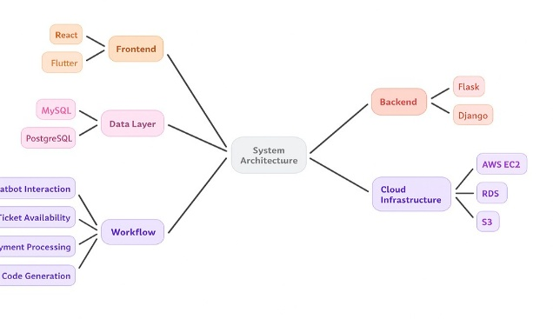

Figure 1: System Architecture – Combining AI and the Cloud to Provide Smooth Ticketing Experience

A smart multi-level architecture that marries chatbot workflow, data handling and cloud scale.

Figure 1: Proposed AI-Powered Chatbot Ticketing System – The Image Source The proposed AI-Powered Chatbot Ticketing System, as depicted is the diagrammatic representation comprises of four main building blocks in its system architecture; Frontend, Backend, Data Layer and Cloud Infrastructure integrated with a Workflow that connects these components.

The Frontend by Icon-science is a state-of-the-art, responsive and user-friendly chatbot interface for end-users to interact with on their browser. BackEnd, powered by frameworks such as Flask or Django, performs all the business logic, chatting with a chatbot and interacting with the NLP engine. Museum information, user query, and transactional details are kept in a secure MySQL/PostgreSQL Data Layer. Its cloud-based infrastructure runs on AWS, including EC2, RDS and S3 to ensure scalability, data retention and high availability.

Last but not least, there’s Workflow controlling chatbot communication, ticket availability, payment handling and code generation – a seamless and brilliant user experience. This structure is robust, efficient and modern-museum-ticketing-aware.

V. RESULTS

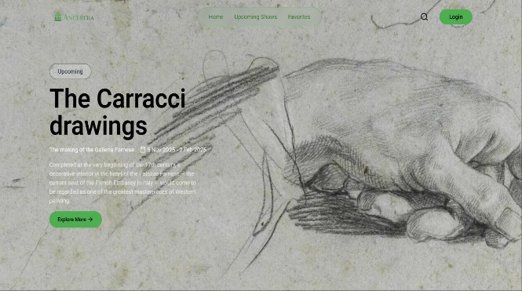
Figure 2: The Carracci Drawings- Art and technology meld into one.

Where tradition interacts with the future in one digital experience.

The figure 2 is a digital page belonging to an exhibit at Ancestra, “The Carracci Drawings”, where art and technology harmoniously integrate to improve the overall museum experience. Its also well-organized and easy for visitors to search for upcoming shows and events. Serving the contemporary museum, chatbot systems underpinned by AI of these venues help users to reserve tickets and for mounting questions as well as their response to exhibitions hosted at a given moment.
This blending of culture and innovation makes tours quicker, easier and more enjoyable while bringing cultural institutions closer to the people of the world in a far more approachable and inclusive way.

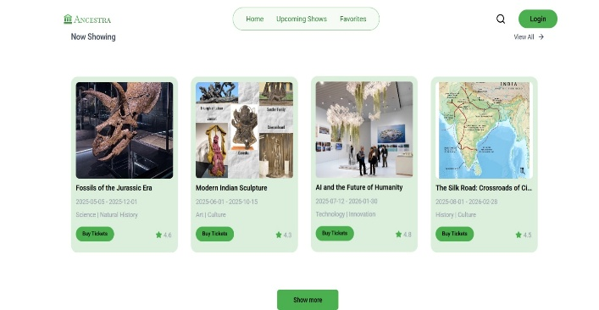

Figure 3: Exploring-Art Science Innovation Together.
Collapsing the past, present and future of culture into one digital space.

This figure 3 Now Showing of the Ancestra museum. It presents a range of exhibitions currently in progress, including Fossils of the Jurassic Era Modern Indian Sculpture The Silk Road: Crossroads of Civilizations AI and the Future of Humanity Every card displays event dates, themes, ratings and a direct link to purchase tickets immediately.
As design and integration indicate, an AI-based a chatbot system could indeed make ticket booking and event discovery frictionless, faster, and engaging. It represents the aspirations of integrating education as well as art and technology in a seamlessly all inclusvie, personalized cultural sharing experience that interacts with user’s interests instantaneously.

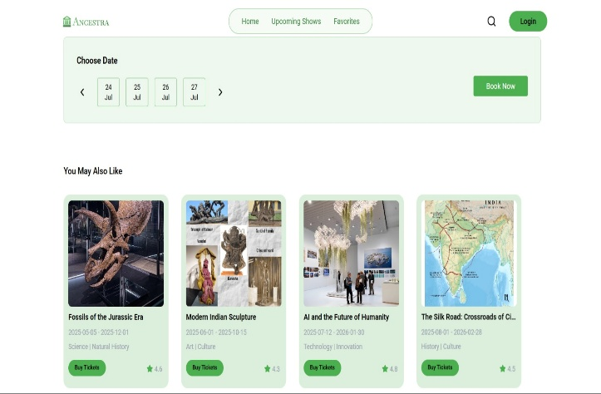

Figure 4: Smart Booking Interface – Simplifying Cultural Access with AI
When convenience and curiosity collide in smart design.
The figure 4 is a smart reservation interface of the Ancestra application for fast booking museum tickets. Guests can simply select their date from a calendar and pay in a click. What’s more, under the booking section, it’ll cleverly suggest related shows visitors might like too - such as Fossils of the Jurassic Era, Modern Indian Sculpture and AI and the Future of Humanity - which will help keep users browsing.

This interface is indicative of how personalization with AI and conversational chatbots will create a more intuitive, fun experience for visitors. Adding intelligent suggestions and automatic booking make the system easily available, effective and friendly to a wide range of users throughout the world.

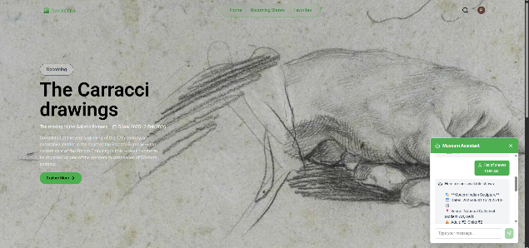

Figure 5: Screenshot of an interactive homepage for the Ancestra system with “The Carracci Drawings” exhibition and chatbot for real-time help using AI.
The Figure 5 is also an interface front page of the Ancestra AI-Powered Museum Ticketing System, which provides a full immersion glance for the users to know about something in advance that will happen on the art exhibition.

The Featured Exhibition, "The Carracci Drawings," brings to the national spotlight dazzling works from Galleria Farnese, one of the masterpieces of 17th century Western art. This show, from 5th November to 2nd February 2026, is an opportunity for the visitor to be immersed into the rich art and elaborate sketches that set the stage of modern art.

The interface is well-designed and uses a soft, sketched background that performs the double duty of setting the mood for this museum-like visual. Home, Upcoming Shows and Favorites speak for themselves but Navigation isn’t lost on the screen – why not keep it in established areas of user ‘focus’? A prominent “Explore More” button prompts exhibition information seekers to explore show details, artist bio information, and ticket info.

In addition, the Museum Assistant Chatbot located at the bottom right corner brings some intelligent interactive content to the website. This bot provides all visitor with information on available exhibitions through the name, date and location of exhibition as well the ticked type associations. For instance, it lists information about a Modern Indian Sculpture exhibition in the National Gallery of Modern Art, Delhi, and does so by answering user queries that have a certain human-like quality.

This is the ideal union of AI-powered and cultural storytelling in this system; a fusion of eye candy and smart automation. In fact, in merging aesthetics, accessibility and real-time interactivity on this page, it is a brilliant case study for how technology can reimagine the digital museum experience and inspire audience engagement.

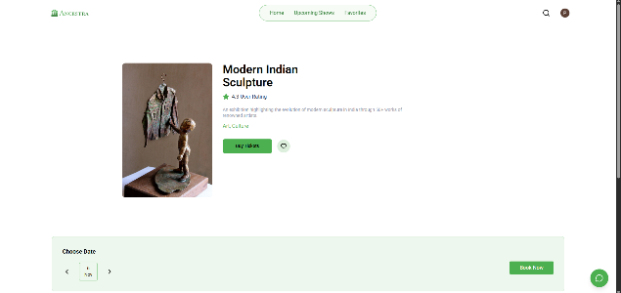

Figure 6 : Booking screen for ‟Modern Indian Sculpture” displaying exhibit information and easy ticket selection system.

This image 6represents the booking interface for the exhibition “Modern Indian Sculpture” with Ancestra Ai-Powered Ticketing System. The simplicity and user interactivity in design is mixed with the animation work of modern Indian artist. 047The second bronze sculpture, as an emblem of modern expression and human feelings to anchor our page here by sight, yet still containing a certain invitation to delve.

The interface has allowed light to be shone on core event information like the exhibition’s name, user rating (4.3 star) and short description with a focus on its theme at heart - which depicts how modern sculpture in India has evolved through that years by work from over 50 leading artists of country. Under that is tags, categorized such as Art & Culture so that the users can find out in a glance what this exhibition is about.

The ‘Buy Tickets’ button takes you through to purchasing tickets, and the heart icon creates a list of favourites for those visitors who fancy taking in some shows. The date selector at the bottom is very simple to use and you can jump around between exhibition dates so it’s quite fun actually. The "Book Now" button brings the call to action and usability further into focus.

Besides, it's in keeping with the minimalist and green color branding of the Ancestra platform. The top-navigation bar allows for fast access to Home, Upcoming Shows and Favorites - in addition to a back button - that allows visitors to effortlessly jump between numerous shows and not lose their way.

In conclusion, This face to fits together the appreciation of art and technology perfectly by allowing them to appreciate cultural heritage over a clean and intuitive responsive layout for booking that will follow up with presentation experience at digital museum.

VI. SECURITY AND PRIVACY CONSIDERATIONS

It should be designed with data privacy regulations in mind.

A. Data Protection Compliance

The platform is compliant with global standards such as GDPR and CCPA. Customer data (name, email address and transaction history) is pseudonymised and impossibility encrypted with the latest encryption technology like AES-256. A transparent and readily available policy on privacy is necessary in order to employ the system.

B. Secure Transactions

As stated in Section IV-B, the system is Tokenization powered through payment gateway and it never stores actual credit cards. HTTPS/TLS secures all communication between the Presentation and Application layers.

C. Integrity and Reliability

The tool also comes with strong error handling and logging support. Cloud-based redundancy guarantees high availability, eliminating the service chaos central to real-time ticketing.

VII. CONCLUSION AND FUTURE WORK

The Discover passage AI-Driven Chatbot Based Ticketing System for Museums streamlines outdated ticketing methods and enhances the visitor experience.
Utilizing advanced NLP techniques, the system provides a quick, accurate, multi-lingual and secure method for making reservations and requesting information. It allows for cultural institutions to optimize performance, data driven decision making, it's accessible to a variety of users.

Future work will also entail adding more advanced AI functionalities, such as:

-Bespoke Options: Suggesting bespoke ticket bundles or exhibit suggestions based on a user’s history and explicitly stated preferences throughout the conversation.

Voice Interface: Enhancing the interface to also enable voice-controlled, automated booking.

Dynamic Pricing: Add an AI segment that checks current demand and the best prices for ticketing.

This project models a scalable approach to how museums might connect technology and cultural heritage in meaningful ways.

REFERENCES

[1] Chatbot Implementation and Evaluation in E-Commerce Customer Service. Journal of Business Research, 2021.

[2] Conversational Agents for Cultural Heritage: A Survey of Museum Chatbot Applications. International Journal of Heritage Studies, 2019.

[3] The Impact of Multilingual AI on Global Tourism: A Case Study in Reservation Systems. Tourism Management, 2022.

[4] Real-Time Analytics for Operational Excellence in Service Industries. IEEE Transactions on Systems, Man, and Cybernetics, 2020.

[5] A Natural Language Processing Approach to Intent Classification and Entity Extraction for Dialogue Systems. Conference on Computational Linguistics, 2018.

[6] Securing Financial Transactions in E-Ticketing Systems: A Cryptographic Perspective. Journal of Cybersecurity, 2023.

[7] Ethical AI and Data Privacy in Customer-Facing Applications. AI & Society, 2021.

[8] Scalable Cloud Architectures for High-Availability Web Services. Cloud Computing Research Conference, 2019.

